Heparin Disaccharide HD008

Catalogue no: HD008
Batch no: BN3
Molecular weight: 503
Molecular Formula: C₁₄H₁₉NO₁₄SNa₂
Structure: HexA – GlcNAc,6S
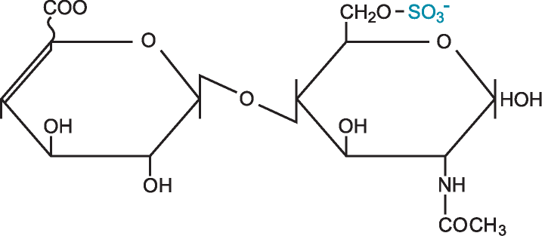

Quantity: 1mg per vial
Appearance: White/yellow powder
Origin: High quality porcine mucosal heparin
Specification | Result
Purity >95% by HPLC | ≤98%
Degree of polymerisation by gel filtration | 2-mer/disaccharide
SAX 0 – 1M NaCl over 45minutes detected at 232nm
Bimodal profile – separation of α and β anomers
Please note; elution times may vary slightly according to HPLC conditions.

