Heparin Disaccharide HD007

Catalogue no: HD007
Batch no: BN3
Molecular weight: 503
Molecular Formula: C₁₄H₁₉NO₁₄SNa₂
Structure: ∆UA,2S – GlcNAc
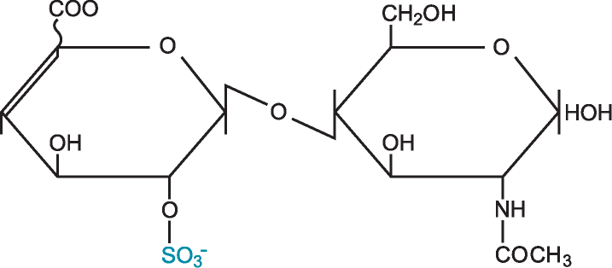

Quantity: 1mg per vial
Appearance: White/yellow powder
Origin: High quality porcine mucosal heparin
Specification | Result
Purity >95% by HPLC | 98.6%
Degree of polymerisation by gel filtration | 2-mer/disaccharide
SAX 0 – 1M NaCl over 45minutes detected at 232nm
Please note; elution times may vary slightly according to HPLC conditions.

