Heparin Disaccharide HD006

Catalogue no: HD006
Batch no: BN3
Molecular weight: 401
Molecular Formula: C₁₄H₂₀NO₁₁Na
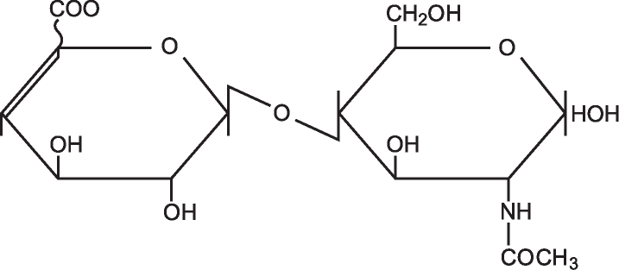
Structure: ∆UA – GlcNAc

Quantity: 1mg per vial
Appearance: White/yellow powder
Origin: High quality porcine mucosal heparin
Specification | Result
Purity >95% by HPLC | >99%
Degree of polymerisation by gel filtration | 2-mer/disaccharide
Date of test: 6/12/16
SAX 0 – 1M NaCl over 45minutes detected at 232nm
Please note; elution times may vary slightly according to HPLC conditions.

