Heparin Disaccharide HD005

Catalogue no: HD005
Batch no: BN3
Molecular weight: 461
Molecular Formula: C₁₂H₁₇NO₁₃SNa₂
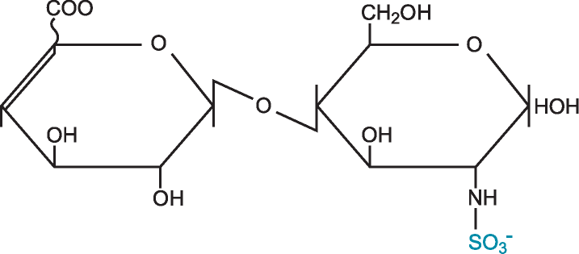
Structure: ∆UA – GlcNS

Quantity: 1mg per vial
Appearance: White/yellow powder
Origin: High quality porcine mucosal heparin
Specification | Result
Purity >95% by HPLC | 97%
Degree of polymerisation by gel filtration | 2-mer/disaccharide
Date of test: 13/4/15
SAX 0 – 1M NaCl over 45minutes detected at 232nm
Please note; elution times may vary slightly according to HPLC conditions.

