Heparin Disaccharide Standard HD001

Catalogue no: HD001
Batch no: BN2
Molecular weight: 665
Molecular Formula: C₁₂H₁₅NO₁₉S₃Na₄
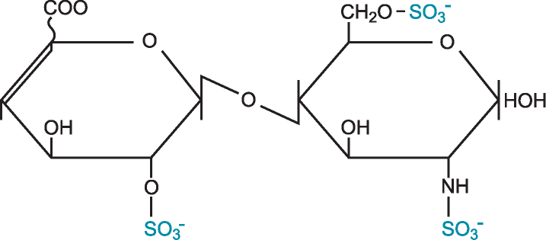
Structure: ∆UA,2S – GlcNS,6S

Quantity: 1mg per vial
Appearance: White/yellow powder
Origin: High quality porcine mucosal heparin
Specification | Result
Purity >95% by HPLC | ≥99%
Degree of polymerisation by gel filtration | 2-mer/disaccharide
SAX 0 – 1M NaCl over 45minutes detected at 232nm
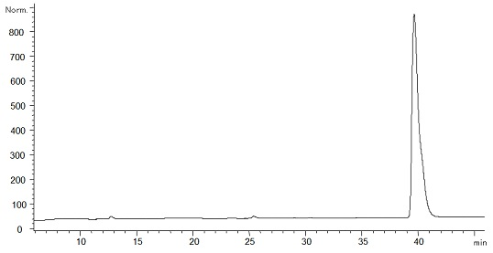
Please note; elution times may vary slightly according to HPLC conditions.

