Chondroitin/Dermatan Sulphate Disaccharide

Catalogue no: CD004
Batch no: BN2
Molecular weight: 605
Molecular Formula: C₁₄H₁₈NO₁₇S₂Na₃
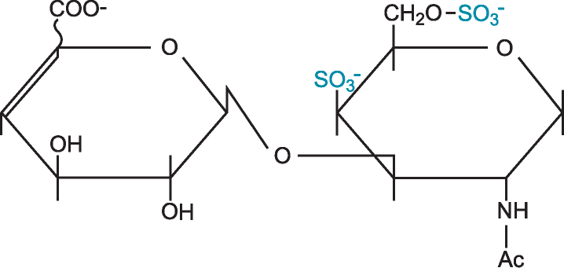
Structure: ∆UA – GalNAc, 4S, 6S (diE)

Quantity: 500ug per vial
Appearance: White/yellow powder
Origin: High quality porcine mucosal heparin
Specification | Result
Purity >90% by HPLC | 94.8%
Degree of polymerisation by gel filtration | 2-mer/disaccharide
Date of test: 15/7/15
SAX 0 – 1M NaCl over 45minutes detected at 232nm
Bimodal profile – separation of α and β anomers
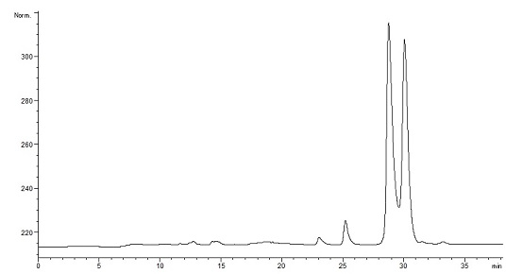
Please note; elution times may vary slightly according to HPLC conditions.

