Chondroitin/Dermatan Sulphate Disaccharide

Catalogue no: CD002
Batch no: BN1
Lyophilisation date: 12/10/15
Molecular weight: 503
Molecular Formula: C₁₄H₁₉NO₁₄SNa₂
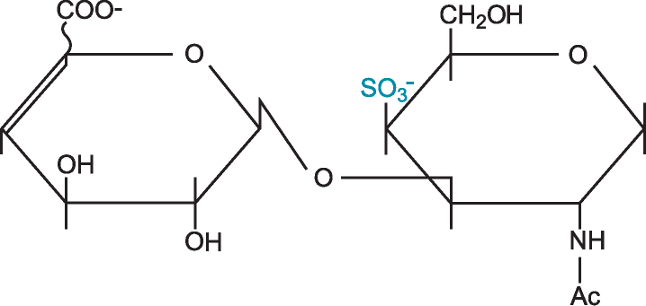
Structure: ∆UA – GalNAc, 4S

Quantity: 1mg per vial
Appearance: White/yellow powder
% Water: 17.45
% Sodium: 13.37
Origin: High quality porcine Chondroitin/dermatan sulphate
Specification | Result
Purity >90% by HPLC | 95%
Degree of polymerisation by gel filtration | 2-mer/disaccharide
SAX 0 – 1M NaCl over 45minutes detected at 232nm
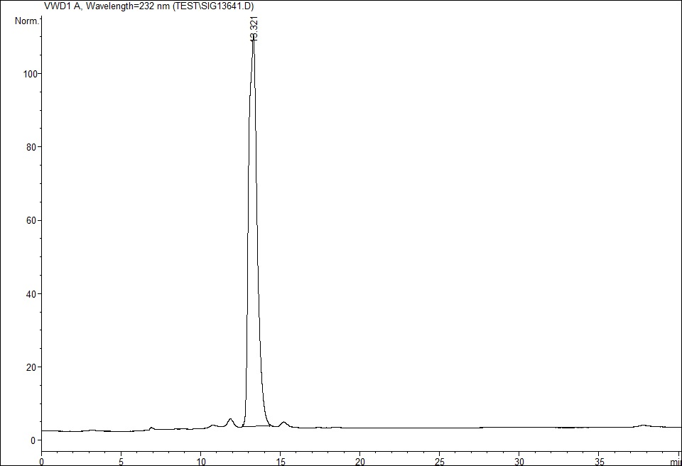
Please note; elution times may vary slightly according to HPLC conditions.

