Chondroitin/Dermatan Sulphate Disaccharide Mix

Catalogue no: CS/DS Mix
Batch no: 1
Information: Chondroitin/Dermatan (CS/DS) Sulphate Disaccharide Mix – catalogue numbers CD001 – CD008 dissolved in water at approx. equal molar concentrations.
CS/DS Disaccharide Standards in 100ul of HD Mix were resolved on a Supelcosil LC anion exchange HPLC column using a sodium chloride gradient of 0 to 1M NaCl in water pH3.3 over 2 hours.
The disaccharides were detected by UV at wavelength of 232nm by virtue of their unsaturated bond. Each pack size contains 10 x 100µl applications.
The exact salt concentration required to elute each sample will vary with column type and manufacture.
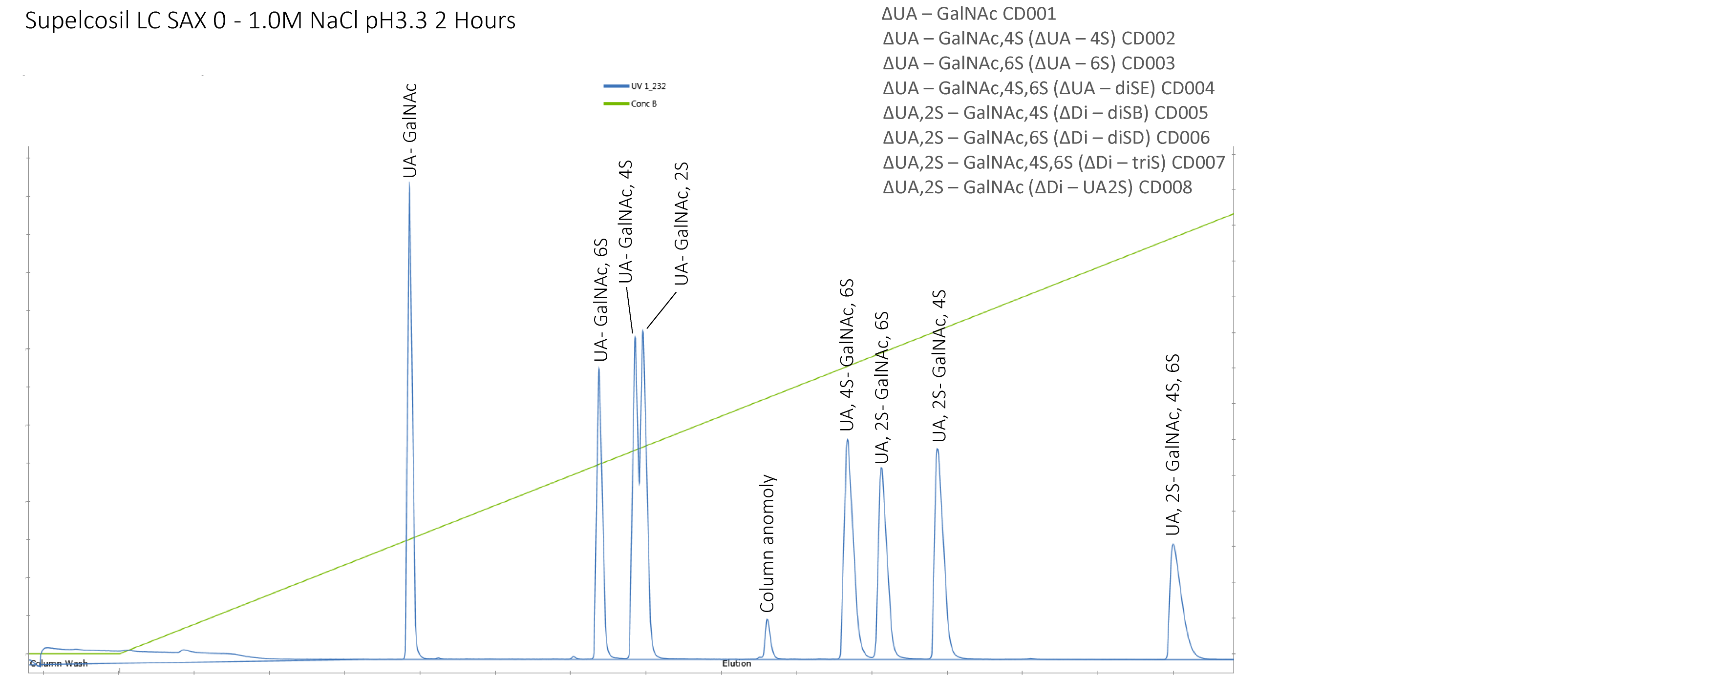

Quantity: 1ml per vial
Appearance: Clear solution
Origin: High quality chondroitin and dermatan sulphate
Toxicity and Hazards: We are not aware of any toxicity associated with this product. In common with good laboratory practice the material should only be handled by qualified personnel in laboratory procedures and familiar with potential hazards. These products are not intended for human consumption, drug use or any form of human experimentation.
Applications: Biological/biochemical laboratory research
Storage/expiry: 12 months from delivery date when stored at -20°C

Warranties: Iduron warrants that its products shall conform to the description of such products as provided in Iduron’s catalogue. This warranty is exclusive, and seller makes no other warranty, expressed or implied, including any implied warranty of merchantability or fitness for any particular purpose. See ‘terms and conditions’ for further warranty information.

